Objective
The objective of this Standard Operating Procedure (SOP) is to outline the process to control changes to approved Engineering design data.
This SOP defines the process in managing internally and externally originated changes to Engineering Product designs after it has been baselined; both hardware and software changes are considered.
For changes originating during the design process, prior to baselining, refer to ENG-P-830-01 Design and Development of Product and Services.

Applicability
This SOP is to control changes made during, or subsequent to, the design and development of products and services, to the extent necessary to ensure that there is no adverse impact on conformity to requirements.

Responsibilities
The Vice President (VP) Engineering is responsible for the development and approval of this SOP.
In support of VP Engineering, the Design Assurance and Engineering Quality Manager is responsible for the updating and distribution of this SOP, as well as any required training.

Definitions
AMDT Change | A change that, due to its scope, requires an Amendment to be incorporated into a unit to be changed as detailed in Airbus Change Process. The part number does not change.
Change Description Report | A Change Description Report is required to document the investigation into an incident and describe the design change required as a result.
Electronics Manufacturer | A party that designs and manufactures electronic components to be used in the installation and collaborates with both the seat supplier and the TC/ATC/STC applicant/holder. The electronics manufacturer may be a production approval holder.
JIRA | Issue tracking tool. It is a truncation of GOJIRA, the Japanese word for Godzilla.
Kanban | A Kanban board is a JIRA tool for agile project management tool designed to help visualize workflow.
Minor Change Agreement | MCA: An agreement between the FAA ACO and the supplier that defines the assessment process of changes to FAA PMA parts or FAA STC that results in a Minor Change Description (MCD).
Minor Change Assessment | MCA: The assessment completed to determine if a change is a Type 1 or Type 2. Refer to the Appendices in the Minor Change Agreement for the criteria.
Minor Change Description | MCD: This is the document that describes the design data being changed, the change classification, basis for the classification and, for Type 2 changes, the DER concurrence.
Minor Change | A Minor Change is a change that has “No appreciable effect on the weight, balance, structural strength, reliability, operational characteristics, or other characteristics affecting the airworthiness of an aircraft, aircraft engine or propeller” (FAA and CASA)
MRB Design Change Disposition Agreement | An agreement between the FAA ACO and the supplier that defines the assessment process of minor changes to FAA PMA parts applicable only to a specific serial or batch.
Part Number Change | A change that, due to its scope, require the part number of a unit to be changed as detailed in OEM Change Processes.
Statement of Compliance | SOC: Defines engineering changes to software for FAA PMA parts or EASA/FAA STC.
Type 1 Minor Change | A Minor Change that matches one or more of the description of changes listed in Appendix B of 827REP00072 Minor Change Agreement between Burrana and the Denver FAA ACO.
Type 2 Minor Change | A Minor Change that matches one or more of the description of changes listed in Appendix C of 827REP00072 Minor Change Agreement between Burrana and the Denver FAA ACO.

Acronyms
ACO | Aircraft Certification Office
AMDT | Amendment (Airbus abbreviation), equivalent to Modification
ATP | Acceptance Test Procedures
CAR | Corrective Action Request:
CCB | Change Control Board
DDP | Declaration of Design and Performance
DER | Designated Engineering Representative
EASA | European Aviation Safety Agency
ECN | Engineering Change Note
EDES | Evolution Definition Evolution Sheet
EDR | Engineering Disposition Report
EM | Electronics Manufacturer
FAA | Federal Aviation Administration
MCA | Minor Change Agreement/Assessment
MCD | Minor Change Description
NAA | National Airworthiness Authority
NOC | Notice of Change
NOE | Notification Of new Equipment/System/Function Process
ODA | Organization Designation Authorization
PMA | Parts Manufacturing Approval
RAC | Request Authorization of Change
SB | Service Bulletin
SCN | Supplier Change Notifications
SOC | Statement of Compliance
SOP | Standard Operating Procedure
STC | Supplemental Type Certificates
TBD | To Be Determined
TC | Type Certificate
TSO | Technical Standards Order
VP | Vice President
WI | Work Instruction

Process
This SOP includes details of the reviews and approvals associated with changes to type design data, the approved documentation required to implement the change and the respective tracking tools.
Changes can originate from several sources and activities, including:
- Obsolescence of parts or materials
- Customer feedback, complaint or request
- Regulatory requirement
- Internal reviews or investigations
- Internal issues register
- Product Improvements
- Poor reliability of a Product
Some of these may result in a Corrective Action Request (CAR) being raised; refer to QMS document Control of Non-Conforming Outputs (P-870-01).
These changes may require one or more approvals, refer QMS documents Change Control Board (ENG-W-836-10), Engineering Drawings – Creation and Approval (ENG-W-835-01), FAA Minor Change (ENG-W-836-02), or Engineering Disposition (ENG-W-836-17). In addition, changes may need to be communicated to the relevant TC, STC or TSO holders by the processes detailed in QMS documents Airbus Change Process (ENG-W-836-08), Boeing Change Process (ENG-W-836-12), or TSO Change Process (ENG-W-836-18) as applicable.
Note that a change may impact more than one of the approval authorities. Review the change classification against all authorities before proceeding with any change requests. The authorities may have different classifications for changes that may, in some cases, require a part number change for one but not the other. In this case discuss with the authorities concerned.
If the change is a result of a safety event, FAA or relevant OEM/NAA shall be notified by QMS document Safety Event Reporting and Investigation (ENG-W-836-07).
If required, Engineering can provide interim information through an Engineering Change Note (ECN) that allows the originator (Operations, Maintenance Repair Organisation (MRO) etc.) to continue work whilst the change data is approved. The ECN does not allow any Product (part, installation design etc.) to be released, until the updated data has been approved.
For legacy items, the updated drawing can include a reference to the ECN where the ECN identified that incorporating the ECN ‘rolls’ the revision, i.e. R01 plus ECN is R02. Where the ECN is referenced in an updated drawing, that ECN is to be also referenced in any notice of change documents. Note that new Burrana products do not roll revisions

Change Classifications
In accordance with aviation regulations, all changes in Type Design must be approved. The following sections describe the classification of changes by Airbus, Boeing, FAA, and TSO holders.
Note that Airbus and Boeing require the change requests to be approved prior to the documents being updated, whereas the FAA require the completed documents to review and approve. For TSO changes, refer to individual working agreements.

Airbus Changes
The Airbus change process commences after the Declaration of Design and Performance (DDP) has been delivered to Airbus. Changes to products that belongs beneath the Airbus’ Design Organisation Approval (DOA) and thus are detailed in the DDP follow the Airbus change processes per ENG-W-836-08.
For Airbus, the change classification-criteria defined in ADB0100-g2-2.7 (and explained more in detail in WD1701923) are applicable, these are defined further in ENG-W-836-08:
- Equipment Modification (Part Number) Change
- Equipment Amendment Changes
- Other Changes

Boeing Changes
For Boeing the change classifications are detailed in ENG-W-836-12, and listed below:
- Equipment Part Number Change
- Other Changes
- Request Authorization of Change / Supplier Change Notifications (RAC/SCN) Changes

FAA Changes
All changes to FAA approved data are assessed as either Minor or Major; these terms are defined by the regulatory authorities as follows:
- A Minor Change is a change that has “No appreciable effect on the weight, balance, structural strength, reliability, operational characteristics, or other characteristics affecting the airworthiness of an aircraft, aircraft engine or propeller” FAA
- A Major Change is a design change that is not classed as Minor (FAA).
If in doubt, either seek advice from the airworthiness authority or delegate or assume it is a Major Change.
Refer to ENG-W-836-02 for further details of these change classifications.

TSO Changes
A change to the electronic component attributes approved under a TSO are assessed as either a Class 1 Change, or a Class 2 Change as detailed in ENG-W-836-18:
- Class 1 Change is a design change to electronic components, or their attachment to the seat, with potential impact to the TSO attributes
- Class 2 Change is a design change to electronic components, or their attachment to the seat, with no potential impact to the TSO attributes

Burrana Change Approval
All changes to controlled engineering data are to be assessed by the Burrana Change Control Board (CCB). There are two CCBs that:
- Determine the need for a change and initiating an investigation into the impact of the change
- Review the investigation and authorising, or rejecting, the implementation of the change.
Figure 1 shows an abbreviated flow for the CCBs. For further details of the CCB activities refer to ENG-W-836-10 Change Control Board.

External Approvals
All Burrana’s designs require approval to be installed on aircraft. This is either through a NAA (e.g. FAA) or a delegated organisation (e.g. Airbus), or as delegated by other organisations.

Change Workflow
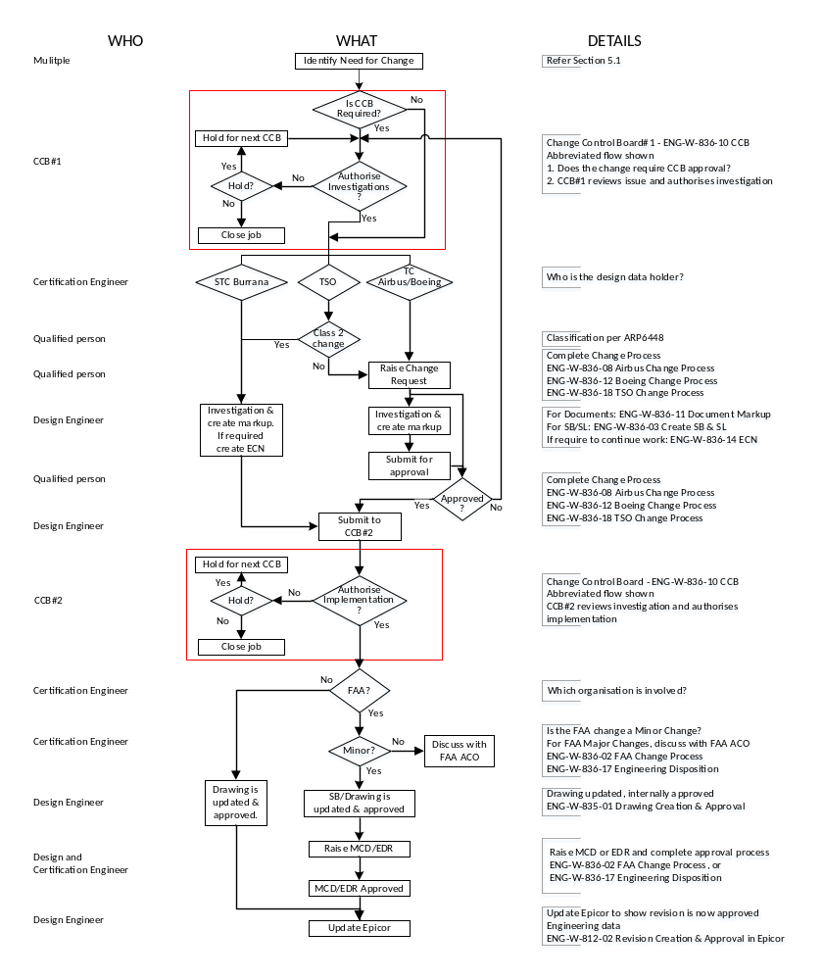
Figure 1 Change Process

Records
- Internal Audit Reports
- Continuous Improvement Actions
- Management Review Outputs

Governing Standards
Reference applicable standards and guidelines:
- AS9100
- FAA: 14CFR 21.137(a), 21.137(k) and 21.319
- ISO: 10007 Quality Management – Guidelines for Configuration Management
- Airbus: ABD0100-g2-2.7 Iss B
- ARP6448
- 827REP00072 Minor Change Agreement between Burrana and the Denver ACO
- 827000169-450 MRB Design Change Disposition Agreement
- FAA AC21-49 Gaining Approval of Seats with Integrated Electronic Components

Related Processes
- ENG-P-812-03 Engineering Configuration Management

Training
All employees of Burrana are trained in this procedure.

Opportunities and Risks
The P-600-01 (Planning for the Quality Management System) procedure addresses opportunities and risks (risk-based thinking).
Burrana makes use of organizational knowledge, lessons learned and experience with the activities associated with Improvement to determine opportunities and risks that need to be addressed and which can:
- Give assurance that the procedure can achieve its intended result(s).
- Enhance desirable effects and prevent or reduce undesired effects.
- Achieve improvement.
- Whenever necessary, this information is documented.

